**19.MULTIPLE CURSOR IN PL/SQL**

**CREATE TABLE DEPARTMENTS(DEPARTMENT_ID INT PRIMARY KEY,DEPARTMENT_NAME VARCHAR(20));**

**INSERT INTO DEPARTMENTS VALUES(10,'CSE');**

**INSERT INTO DEPARTMENTS VALUES(11,'Finance');**

**INSERT INTO DEPARTMENTS VALUES(12,'Sales_Department');**

**INSERT INTO DEPARTMENTS VALUES(13,'IT_Department');**

**SELECT *FROM DEPARTMENTS ORDER BY DEPARTMENT_ID;**

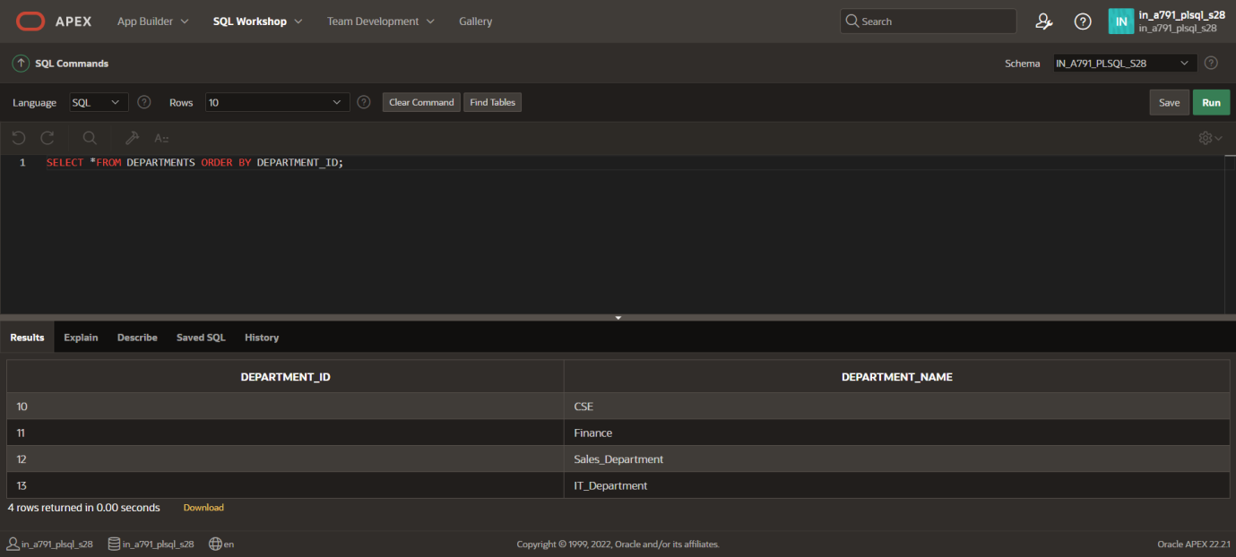

**CREATE TABLE EMPLOYEES101(EMPLOYEE_ID INT PRIMARY KEY,EMPLOYEE_NAME VARCHAR(20),DEPARTMENT_ID INT REFERENCES DEPARTMENTS(DEPARTMENT_ID));**

**INSERT INTO EMPLOYEES101 VALUES(1,'Peter',11);**

**INSERT INTO EMPLOYEES101 VALUES(2,'Ben',13);**

**INSERT INTO EMPLOYEES101 VALUES(3,'Kiran',11);**

**INSERT INTO EMPLOYEES101 VALUES(4,'Shaam',10);**

**INSERT INTO EMPLOYEES101 VALUES(5,'Vinoth',13);**

**INSERT INTO EMPLOYEES101 VALUES(6,'Harsha',12);**

**SELECT *FROM EMPLOYEES101 ORDER BY EMPLOYEE_ID;**

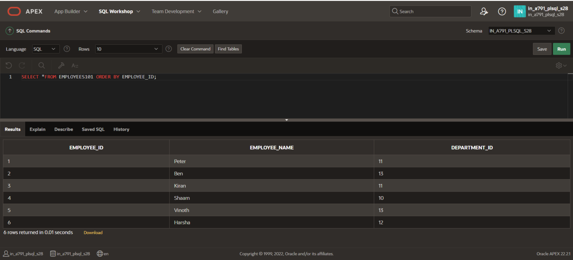

**DECLARE**

**CURSOR dept_cursor IS SELECT department_id, department_name FROM DEPARTMENTS;**

**CURSOR emp_cursor(p_dept_id NUMBER) IS SELECT employee_id, employee_name FROM EMPLOYEES101 WHERE department_id = p_dept_id;**

**v_department_id DEPARTMENTS.department_id%TYPE;**

**v_department_name DEPARTMENTS.department_name%TYPE;**

**v_employee_id EMPLOYEES101.employee_id%TYPE;**

**v_employee_name EMPLOYEES101.employee_name%TYPE;**

**BEGIN**

**OPEN dept_cursor;**

**LOOP**

**FETCH dept_cursor INTO v_department_id, v_department_name;**

**EXIT WHEN dept_cursor%NOTFOUND;**

**DBMS_OUTPUT.PUT_LINE('Department: ' || v_department_name);**

**OPEN emp_cursor(v_department_id);**

**LOOP**

**FETCH emp_cursor INTO v_employee_id, v_employee_name;**

**EXIT WHEN emp_cursor%NOTFOUND;**

**DBMS_OUTPUT.PUT_LINE(' Employee: ' || v_employee_name);**

**END LOOP;**

**CLOSE emp_cursor;**

**END LOOP;**

**CLOSE dept_cursor;**

**END;**

**/**

